Title of Research Paper

Author¹, Author², Author³
Designation, Department, College, City, Country¹
Designation, Department, College, City, Country²
Designation, Department, College, City, Country³

Abstract: This document gives formatting instructions for authors preparing papers for publication in the Proceedings of an International Journal. The authors must follow the instructions given in the document for the papers to be published. You can use this document as both an instruction set and as a template into which you can type your own text.

Keywords: Include at least 4 keywords or phrases.

- INTRODUCTION

This document is a template. An electronic copy can be downloaded from the conference website. For questions on paper guidelines, please contact the conference publications committee as indicated on the conference website. Information about final paper submission is available from the conference website.

- PAGE LAYOUT

An easy way to comply with the conference paper formatting requirements is to use this document as a template and simply type your text into it.

- Page Layout
Your paper must use a page size corresponding to A4 which is 210mm (8.27") wide and 297mm (11.69") long. The margins must be set as follows:
- Top = 20.32mm (0.8")
- Bottom = 20.32mm (0.8")
- Left = Right = 20.32mm (0.8")

Your paper must be in single column format with a space of 4.22mm (0.17") between columns.

- PAGE STYLE

All paragraphs must be indented. All paragraphs must be justified, i.e. both left-justified and right-justified.

- Text Font of Entire Document
The entire document should be in Times New Roman. Type 3 fonts must not be used. Other font types may be used if needed for special purposes.
Recommended font sizes are shown in Table 1.

- Title and Author Details
Title must be in 24 pt Regular font. Author name must be in 11 pt Regular font. Author affiliation must be in 10 pt. All title and author details must be in single-column format and must be centred. Every word in a title must be capitalized except for short minor words such as “a”, “an”, “and”, “as”, “at”, “by”, “for”, “from”, “if”, “in”, “into”, “on”, “or”, “of”, “the”, “to”, “with”. Author details must not show any professional title (e.g. Managing Director), any academic title (e.g. Dr.) or any membership of any professional organization (e.g. Senior Member IEEE).

To avoid confusion, the family name must be written as the last part of each author name (e.g. John A.K. Smith). Each affiliation must include, at the very least, the name of the company and the name of the country where the author is based (e.g. Causal Productions Pty Ltd, Australia).

- Section Headings
No more than 3 levels of headings should be used. All headings must be in 10pt font. Every word in a heading must be capitalized except for short minor words as listed in Section III-B.
Level-1 Heading: A level-1 heading must be in Small Caps, centered and numbered using uppercase Roman numerals. For example, see heading “III. Page Style” of this document. The two level-1 headings which must not be numbered are “Acknowledgment” and “References”.

Level-2 Heading: A level-2 heading must be in Italic, left-justified and numbered using an uppercase alphabetic letter followed by a period. For example, see heading “C. Section Headings” above.
Level-3 Heading: A level-3 heading must be indented, in Italic and numbered with an Arabic numeral followed by a right parenthesis. The level-3 heading must end with a colon.

- Figures and Table
Figures and tables must be cantered in the column. Graphics must not use stipple fill patterns because they may not be reproduced properly. Please use only SOLID FILL colors which contrast well both on screen and on a black-and-white hardcopy, as shown in Fig. 1.

Figure Captions
Figures must be numbered using Arabic numerals. Figure captions must be in 10 pt Regular font. Captions of a single line must be centered whereas multi-line captions must be justified. Captions with figure numbers must be placed after their associated figures, as shown in Fig. 1.

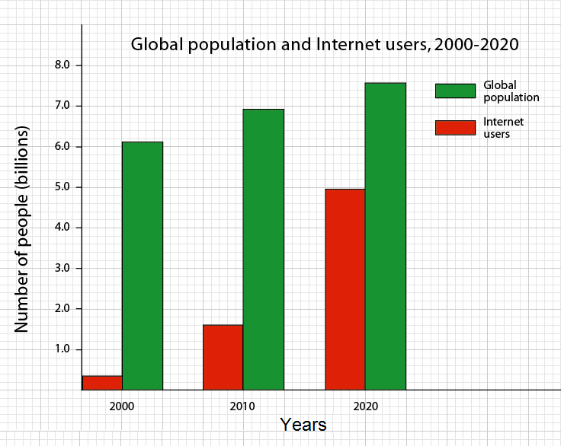

Fig. 1 A sample graph

Table Captions
Tables must be numbered using uppercase Roman numerals. Table captions must be centred and in 10 pt. Captions with table numbers must be placed before their associated tables, as shown in Table 1.

TABLE I FONT SIZES FOR PAPERS

Font  Size | Appearance (in Time New Roman or Times)
 | Regular | Bold | Italic
10 | table caption (in Small Caps), figure caption
8 | reference item |  | reference item (partial)
10 | author address (in Courier), cell in a table | abstract body | abstract heading (also in Bold)
10 | level-1 heading (in Small Caps), paragraph |  | level-2 heading, level-3 heading,  author affiliation
11 | author name
24 | title

- Page Numbers, Headers and Footers
Page numbers, headers and footers must not be used.

- Links and Bookmarks
All hypertext links and section bookmarks will be removed from papers during the processing of papers for publication. If you need to refer to an Internet email address or URL your paper, you must type out the address or URL fully in Regular font.

- References
The heading of the References section must not be numbered. All reference items must be in 8 pt font. Please use Regular and Italic styles to distinguish different fields as shown in the References section. Number the reference items consecutively in square brackets (e.g. [1]). When referring to a reference item, please simply use the reference number, as in [2].

Examples of reference items of different categories shown in the References section include:

- example of a book in [1]
- example of a book in a series in [2]
- example of a journal article in [3]
- example of a conference paper in [4]
- example of a patent in [5]
- example of a website in [6]
- example of a web page in [7]
- example of a databook as a manual in [8]
- example of a datasheet in [9]
- example of a master’s thesis in [10]
- example of a technical report in [11]
- example of a standard in [12]

- CONCLUSION

The version of this template is V2. Most of the formatting instructions in this document have been compiled by Causal Productions from the IEEE LaTeX style files. Causal Productions offers both A4 templates and US Letter templates for LaTeX and Microsoft Word. The LaTeX templates depend on the official IEEEtran.cls and IEEEtran.bst files, whereas the Microsoft Word templates are self-contained.

ACKNOWLEDGMENT <optional>

The heading of the Acknowledgment section and the References section must not be numbered. Causal Productions wishes to acknowledge Michael Shell and other contributors for developing and maintaining the IEEE LaTeX style files which have been used in the preparation of this template.

REFERENCES

- B. McMahan et al., "Communication-Efficient Learning of Deep Networks From Decentralized Data", Artificial Intelligence and Statistics Proc. PMLR, vol. 10, no. 1, pp. 1273-82, 2017.
- C. En Guo, S.-C. Zhu and Y. N. Wu, "Primal Sketch: Integrating Structure and Texture", Computer Vision and Image Understanding, vol. 106, no. 1, pp. 5-19, 2007.
- S. Zhang, C. Zhu, J. K. O. Sin, and P. K. T. Mok, “A novel ultrathin elevated channel low-temperature poly-Si TFT,” IEEE Electron Device Lett., vol. 20, no. 2, pp. 569–571,1999.
- Hogade, N., Pasricha, S. and Siegel, H.J, “Energy and Network Aware Workload Management for Geographically Distributed Data Centers”. IEEE Transactions on Sustainable Computing, vol.7, no. 2, pp.400–413. 2021
- A. Wierman, Z. Liu, I. Liu and H. Mohsenian-Rad, "Opportunities and challenges for data center demand response", Proc. Int. Green Comput. Conf., vol.7, no. 6, pp.1-10, 2014.
- J. D. Jenkins et al., "The benefits of nuclear flexibility in power system operations with renewable energy", Appl. Energy, vol. 22 no. 2, pp. 872-884, 2018.
- Haoying Dai, Yanne Kouomou Chembo, "RF Fingerprinting Based on Reservoir Computing Using Narrowband Optoelectronic Oscillators", Journal of Lightwave Technology, vol.40, no.21, pp.7060-7071, 2022.
- Floris Van den Abeele, Jeroen Hoebeke, Girum Ketema Teklemariam, Ingrid Moerman, Piet Demeester, "Sensor Function Virtualization to Support Distributed Intelligence in the Internet of Things", Wireless Personal Communications, vol.81, no.4, pp.14-18, 2015.
- J. Hwang, J. Kim and H. Choi, "A review of magnetic actuation systems and magnetically actuated guidewire-and catheter-based microrobots for vascular interventions", Intell. Serv. Robot., vol. 13, no. 1, pp. 1-14, 2020.
- D. G. Feitelson, D. Tsafrir and D. Krakov, "Experience with using the parallel workloads archive", J. Parallel Distrib. Comput., vol. 74, no.3, pp. 2967-2982, 2014.
- B. Accou, J. Vanthornhout, H. V. Hamme and T. Francart, "Decoding of the speech envelope from eeg using the vlaai deep neural network", Scientific Reports, vol. 13, no. 1, pp. 812, 2023.
- Serim Lee, Nahyun Kim, Junhyoung Kwon, Gunhee Jang, "Identification of the Position of a Tethered Delivery Catheter to Retrieve an Untethered Magnetic Robot in a Vascular Environment", Micromachines, vol.14, no.4, pp.724, 2023.

BIOGRAPHY <Optional>

Authors have the option to publish a biography together with the paper, with the academic qualification, past and present positions, research interests, awards, etc. This increases the profile of the authors and is well received by international reader.

